SCHOOL NAME: ___________________________ CANDIDATE NAME: __________________________

SHIRE HIGHLANDS EDUCATION DIVISION
2026 MALAWI SCHOOL CERTIFICATE OF EDUCATION MOCK EXAMINATION
GEOGRAPHY
Subject Number: M073/II
Wednesday, 25 March Time Allowed: 2 Hours
(1:00-3:00 PM)
PAPER II
(100 marks)
HUMAN AND ECONOMIC GEOGRAPHY
Instructions

- This paper contains 12 pages please check.
- Write your Full name on top of each page.
- The paper has two sections A and B.
- The number of marks for each answer are indicated against the question.
- In the table provided tick against the
question number you have answered.
- Hand in your question paper to the
invigilator when time is called to stop writing.

Question number | Tick if answered | Do not write in these columns
1
2
3
4
5
 | TOTAL

SECTION A. (75 marks)
Answer all questions in this section in the spaces provided
1a. State any two methods of modern irrigation. (2 marks)
____________________________________________________________________________________________________________________________________________________________________________________
b. Describe any two ways of maintaining surface irrigation. (4 marks)
_______________________________________________________________________________________________________________________________________________________________________________________________________________________________________________________________________________________________________________________________________________________________________
c. Explain any two ways of improving irrigation in Malawi. (4marks)
________________________________________________________________________________________________________________________________________________________________________________________________________________________________________________________________________________________________________________________________________________________________________
d. Mention any two irrigation schemes found in the Southern Region of Malawi. (2 marks)
____________________________________________________________________________________________________________________________________________________________________________________e. Explain any two reasons why surface irrigation methods are not practiced in Israel. (4 marks)
_______________________________________________________________________________________________________________________________________________________________________________________________________________________________________________________________________________________________________________________________________________________________________
f. Mention any two plantation crops grown under irrigation in Israel. (2 marks)
____________________________________________________________________________________________________________________________________________________________________________________

g. Study the irrigation method below and answer this question

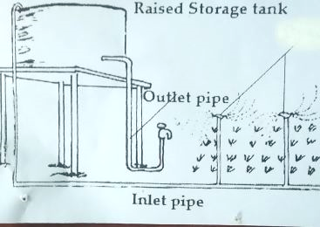

i. Identify the method of irrigation. (1 mark)
__________________________________________________________________________________________
ii. Mention any two disadvantages of this irrigation method. (2 marks)
____________________________________________________________________________________________________________________________________________________________________________________
iii. Identify one cash crop grown under this method of irrigation in Malawi. (1 mark)
__________________________________________________________________________________________
iv. What are the advantages of this method of irrigation? Give three. (3 marks)
________________________________________________________________________________________________________________________________________________________________________________________________________________________________________________________________________________________________________________________________________________________________________
2a. Explain the difference between pelagic and demersal fish. (2 marks)
____________________________________________________________________________________________________________________________________________________________________________________

b. Explain any two human factors that influence development of the fishing industry. (4 marks)
________________________________________________________________________________________________________________________________________________________________________________________________________________________________________________________________________________________________________________________________________________________________________

c. Why is the fishing also known as a robber industry? (2 marks)
____________________________________________________________________________________________________________________________________________________________________________________
d. Why is fishing industry not well developed in the East Africa despite presence of Indian Ocean? Give two reasons. (2 marks)
____________________________________________________________________________________________________________________________________________________________________________________
e. Describe how a drift net is used to catch fish. (5 marks)
__________________________________________________________________________________________________________________________________________________________________________________________________________________________________________________________________________________________________________________________________________________________________________________________________________________________________________________________________
f. Give any two importance of the fishing industry. (2 marks)
____________________________________________________________________________________________________________________________________________________________________________________
g. What is waste? (1 mark)
____________________________________________________________________________________________________________________________________________________________________________________

h. Describe each of the following waste.
i. industrial waste. (2 marks)
____________________________________________________________________________________________________________________________________________________________________________________
ii. Organic waste (2 marks)
____________________________________________________________________________________________________________________________________________________________________________________
i. Describe recycling as a way of waste management. (2 marks)
____________________________________________________________________________________________________________________________________________________________________________________
j. Mention any one economic importance of proper waste management (1 mark)
__________________________________________________________________________________________

3.a i. What is wetland? (1 mark)
____________________________________________________________________________________________________________________________________________________________________________________
Study map of Malawi below. Use it to answer questions 3a ii and 3c.
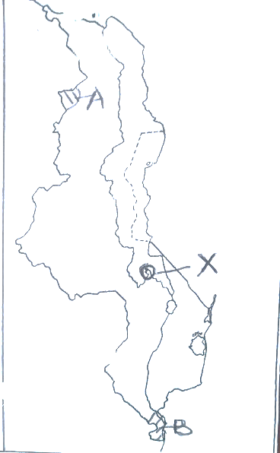
ii. Identify the wetlands marked A and B (2 marks)
________________________________________________________________________________________
iii. Suggest two reasons why wetlands should be maintained and well managed. (4 marks)
________________________________________________________________________________________________________________________________________________________________________________________________________________________________________________________________________________________________________________________________________________________________________
b. i. Define wildlife. (1 mark)
____________________________________________________________________________________________________________________________________________________________________________________

ii. List any two importance of wildlife. (2 marks)
____________________________________________________________________________________________________________________________________________________________________________________
Use Map of Malawi on page… to answer the following questions
c. i. Shade and name the following on the map
1. Liwonde National Park. (2 marks)
2. Nkhotakota Game Reserve (2 marks)
ii. Mention the main wildlife found in National Park marked X. (1mark)
__________________________________________________________________________________________
d. Explain how the following human activities endanger wildlife
i. poaching (2 marks)
____________________________________________________________________________________________________________________________________________________________________________________
ii. Deforestation. (2 marks)
____________________________________________________________________________________________________________________________________________________________________________________
e. Give any two uses of coal (2 marks)
____________________________________________________________________________________________________________________________________________________________________________________

SECTION B (25 marks)
Answer one question from this section in the spaces provided
4a. i. Mention any two methods of underground mining. (2 marks)
____________________________________________________________________________________________________________________________________________________________________________________
ii. Describe how minerals are extracted using panning mining method. (5 marks)
__________________________________________________________________________________________________________________________________________________________________________________________________________________________________________________________________________________________________________________________________________________________________________________________________________________________________________________________________
iii. Mention any one mineral extracted using panning mining method. (1 mark)
__________________________________________________________________________________________
b. i. Define petroleum. (1 mark)
____________________________________________________________________________________________________________________________________________________________________________________
ii. Explain any two conditions necessary for formation of petroleum. (4 marks)
________________________________________________________________________________________________________________________________________________________________________________________________________________________________________________________________________________________________________________________________________________________________________

Study the diagram of oil occurrence process below and answer this question
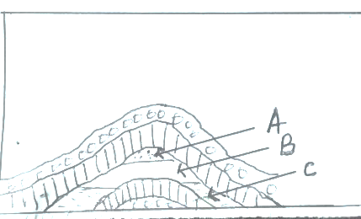
c. Which letter represents oil? Explain your choice. (3 marks)
______________________________________________________________________________________________________________________________________________________________________________________________________________________________________________________________________________
d. Describe the following processes in refinery of oil.
i. fractioning (2 marks)
____________________________________________________________________________________________________________________________________________________________________________________
ii. Thermal cracking (2 marks)
____________________________________________________________________________________________________________________________________________________________________________________
e. Mention any two members of OPEC in Africa. (2 marks)
__________________________________________________________________________________________
f. What is industrialization? (1 mark)
____________________________________________________________________________________________________________________________________________________________________________________

g. List any two advantages of industrialization. (2 marks)
____________________________________________________________________________________________________________________________________________________________________________________
5. a. Study map of the world showing World Sea Routes and answer this question
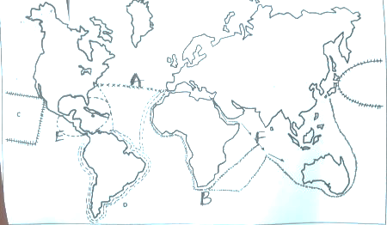
i. Identify the sea routes marked A and B (2 marks)
____________________________________________________________________________________________________________________________________________________________________________________
ii. Mention one main commodity that passes through route B. (1 marks)
____________________________________________________________________________________________________________________________________________________________________________________
iii. Give any two differences between route E and route F (4 marks)
________________________________________________________________________________________________________________________________________________________________________________________________________________________________________________________________________________________________________________________________________________________________________

b. Explain any two importance of world air routes. (4 marks)
________________________________________________________________________________________________________________________________________________________________________________________________________________________________________________________________________________________________________________________________________________________________________
c. Describe any two challenges experienced by Malawi as a landlocked country. (4 marks)
________________________________________________________________________________________________________________________________________________________________________________________________________________________________________________________________________________________________________________________________________________________________________
d. i. Describe how solar energy is produced. (4 marks)
________________________________________________________________________________________________________________________________________________________________________________________________________________________________________________________________________________________________________________________________________________________________________
ii. Give any two advantages of solar energy (2 marks)
____________________________________________________________________________________________________________________________________________________________________________________
e. Study the table below showing energy consumption in Africa and answer this question.
Fuel | World (million tonnes of oil equivalent, mtoe) | Africa (million tonnes of oil equivalent, mtoe)
Oil | 1,610 | 25
Gas | ? | 85
Coal | 3,180 | ?
H.E.P | 630 | 14
Biomass | 600 | 140
Total | 8,760 | 350

- Calculate the amount of gas energy consumed by the world. (2 marks)

- Calculate the amount of coal consumed by Africa (2 marks)

END OF QUESTION PAPER

